KILKENNY COUNTY COUNCIL
CHOICE BASE LETTING (CBL)

APPLICANT USER GUIDE

Contents
Applicant Guide: General Information 3
First Log in 3
Log In 4
Log Out 5
Recover Password via Security Questions 6
Set Up/Update Security Questions 7
Change Password 8
View Help 9
Applicant Guide: Properties 10
Available Properties List 10
Property Details 11
Property Map 12
Add Property to Basket 12
View Properties Basket 13
Remove Property from Basket 13
Check Out / Submit Basket 14
View Reciept 15
View Submitted Properties 16
Remove Interest for Property 16

Applicant Guide: General Information

The Member of the Public accessing the System to browse The Council’s offering under the Choice Based Lettings scheme. This user uses the Choice Based Lettings system in order to express their interest in one or more Properties which will be considered by The Council to allow them to allocate a preferred property to the applicant. This User consumes the application via PC, smartphone or a tablet and is identified by their unique Username.

First Log in
- After receiving the letter with CBL credentials open the CBL Website www.cbl.kilkennycoco.ie using your web browser.

- Following the instructions given in the letter and enter the Username into Username field and the one-time Password into the Password field and click "Log In".

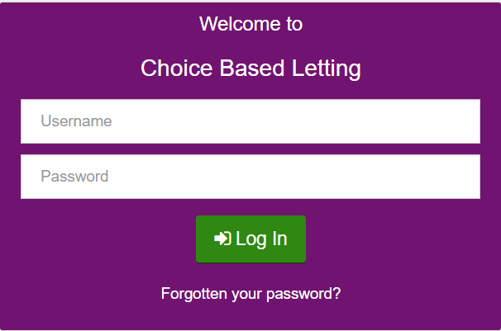

- If you make a mistake inputting these details the System will issue an error message telling you that your credentials are incorrect. If the details entered are correct the System will inform you that the current password is single use only and that it must be changed.

- To achieve this, the System requests you enter a new Password. That Password is required to meet certain complexity requirements and cannot be the same as the one time one. If you enter a password that does not meet the complexity requirements the system will display a message informing you of what is needed to make the correction. In order to submit the new Password, you are requested to input that new Password twice, the second time is for confirmation’s sake and the two must match.

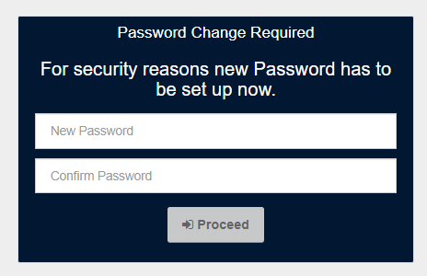

- If you close the browser window or Log Out before changing the password you will be able to use the one-time password again, but if you do the System will still require you to change that password.

- Once you are sure the password meets requirements click the “Proceed” button.

Log In
- Once you have completed the First Log In procedure, when you wish to use the CBL System open the CBL website on your browser.

- When presented with the Log In form provide your Username (which is a combination of your first name, last name and Housing Reference Number) with the current Password and click the “Log In” button.

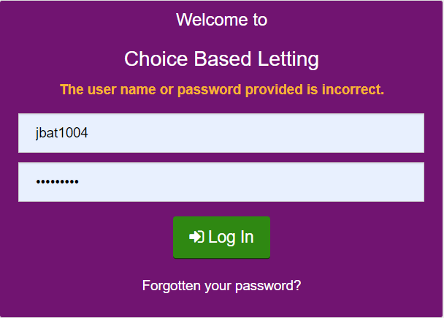

Log Out
- Whenever you are logged into the System you are able to log out. To do so click the “Log Off” link. This button is in the top right corner of the screen.
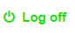
- The System then logs you out of the System and navigates you back to the Log In screen.
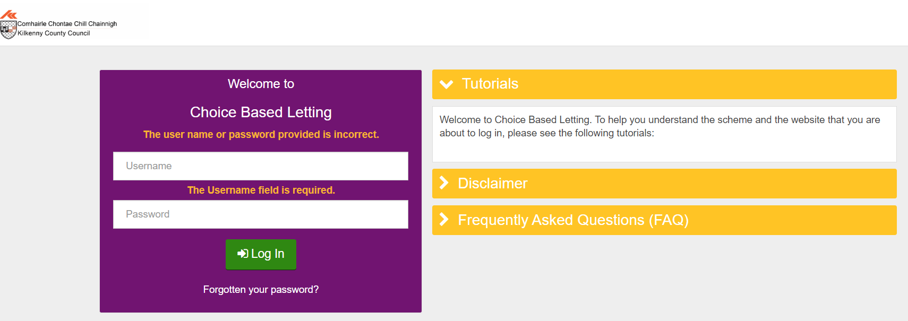

Recover Password via Security Questions
If you have forgotten your Password to CBL System and wish to recover it using security questions, follow these steps:
- Click the "Forgotten Your Password?" link located on the Log In screen.
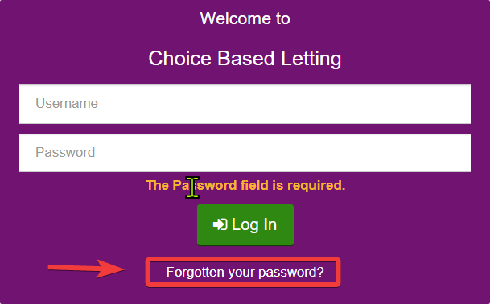
- You are then required to enter your username. Provide your Username and click “Next”.
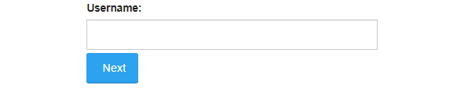
- The system will then provide you with a set of security questions which requires you to select at least one. Once you have selected one and provided an answer click “Verify”.
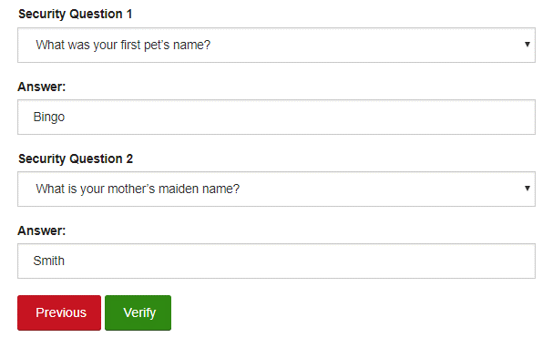
- If the verification is successful, the System allows you to change the Password - the same way as it was performed on the First Log In. Once the password is changed the System will navigate you back to the Log In screen.
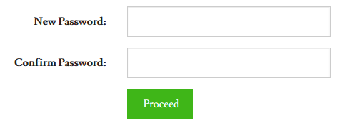

Set Up/Update Security Questions
As an Applicant, after you have successfully logged into the System you are able to update your Security Questions.
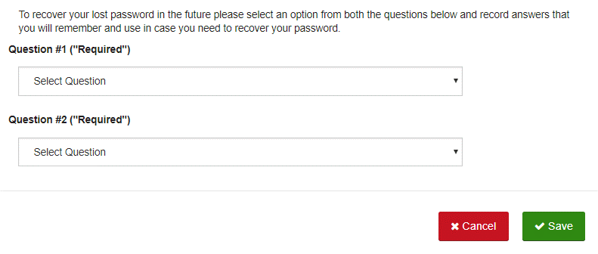
You will be asked to enter these details on first log in but can update these at any time by doing the following:
- Go to “My Details” page and there click the “Update Security Questions” button. On that the System will display a pop-up with two pairs of drop-down and text field (as in: Record Security Questions).
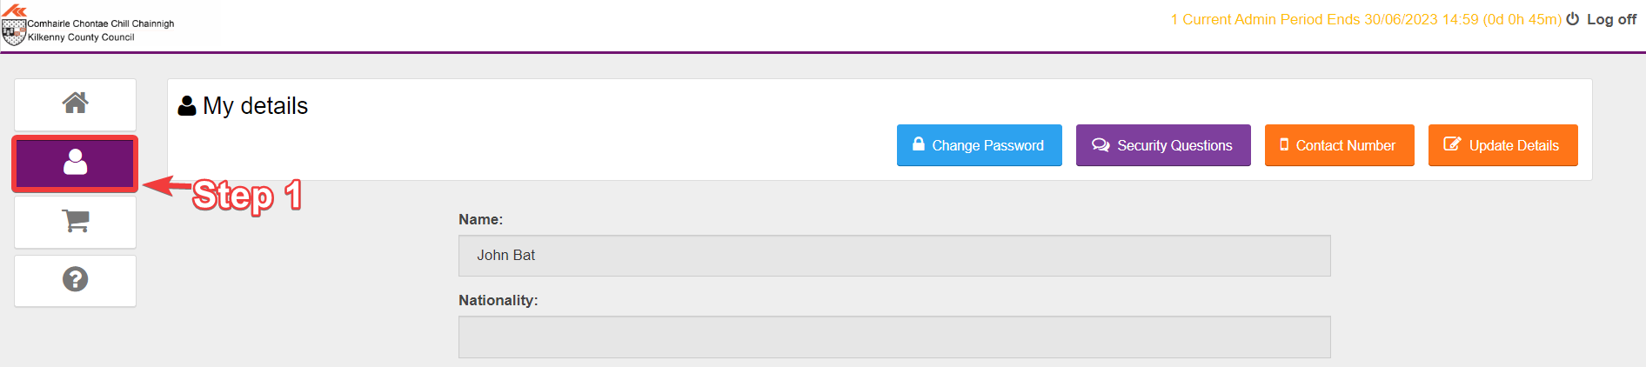
- For every Question you have recorded since the time you first logged into the System the values are prefilled. You can modify both Questions, however if you wish to save, at least one of the Questions must be selected and an answer with of minimal tree characters for it has to be provided. I am also able to discard my changes by clicking “Cancel” button.

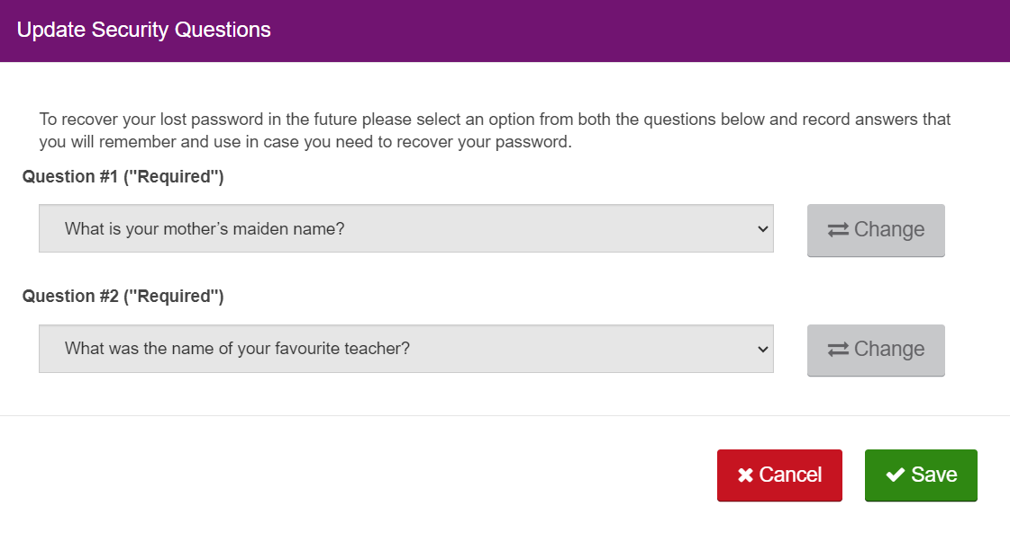

Change Password
After you have successfully logged into the System you are able to change your Password.
- Navigate to the “My Details” page and click the “Change Password” button.
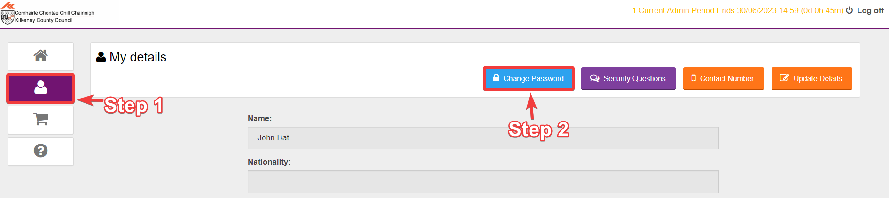
- The System requests you to provide your current password and the new Password. That Password is required to meet the complexity requirements and cannot be the same as the one time one. In order to submit the new Password, you are requested to input that new Password twice, the second time is for confirmation’s sake and the two must match.
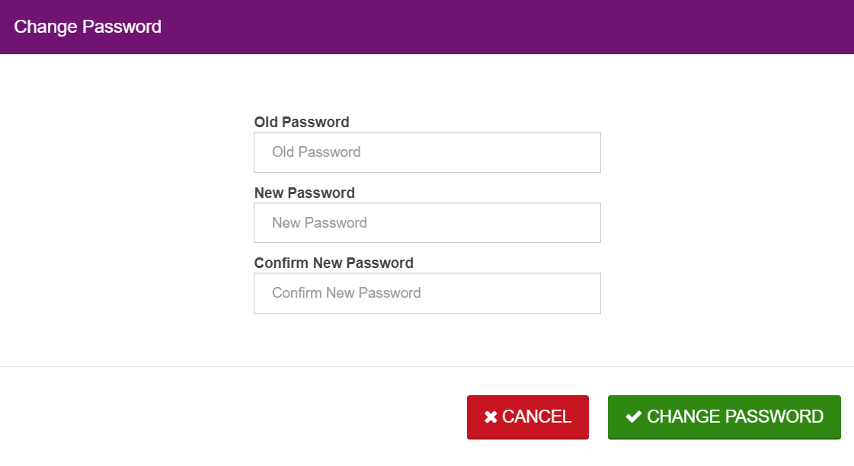
- To submit the change, click “Change Password” and to discard – “Cancel”.
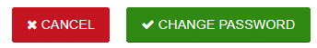

View Help
- To view the help section, select the help button on the left of the screen.
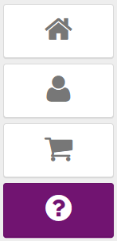
- From here you can view the Help/FAQ and Tutorial sections.

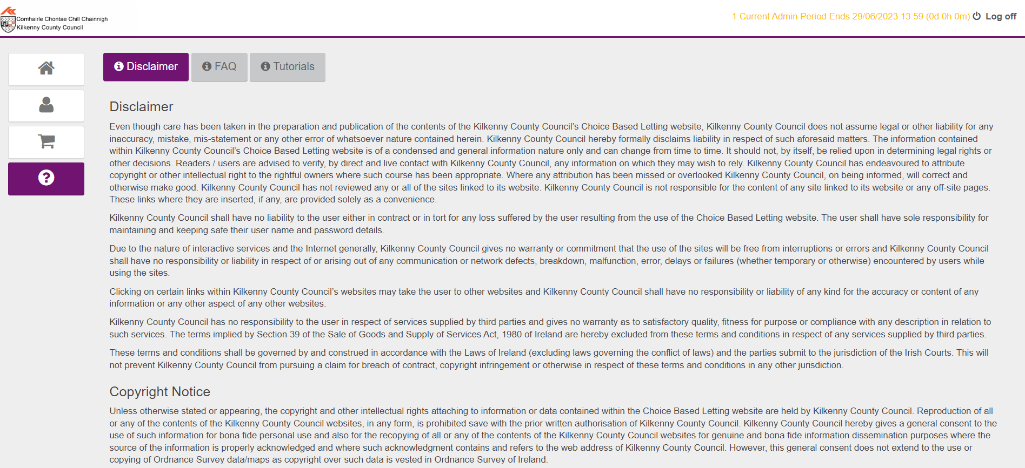

Applicant Guide: Properties

Available Properties List
Once successfully logged into the System you can view all the Properties that are available, this includes properties that:
- Are located in either of your Areas of Choice.
- Are Advertised by The Council.
- Are meeting the number of beds criteria specified by the applicant.
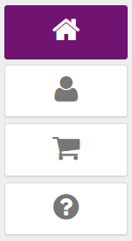
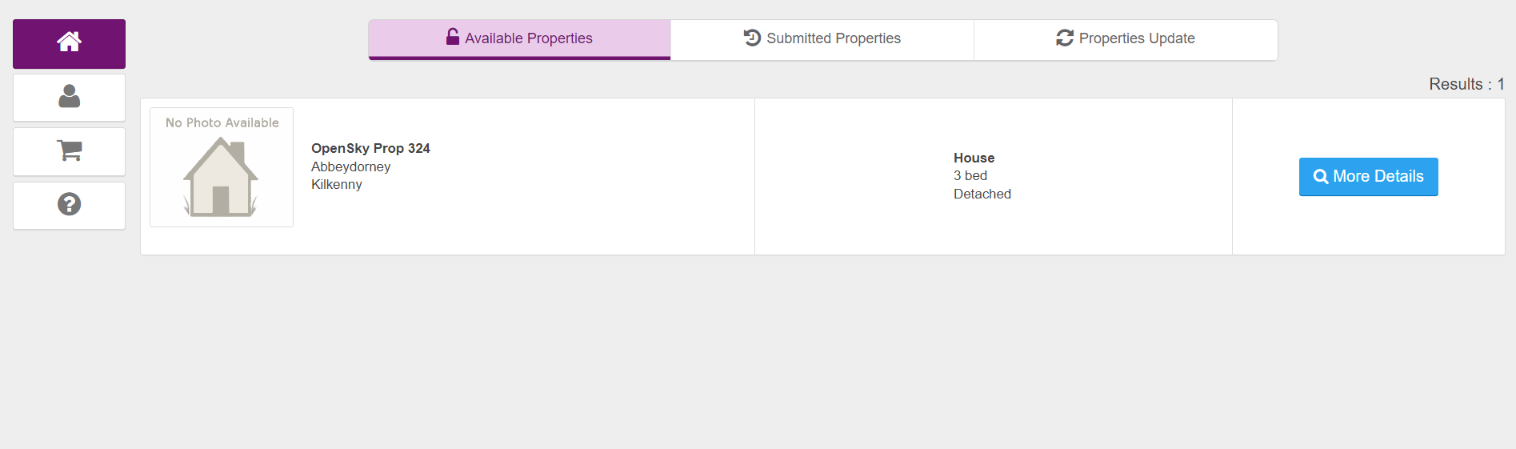
The System displays at maximum 20 Properties at once and if there are more - allows you to navigate to them by selecting to jump to another page. To jump to another page, you must click the next page button or select the page number from the list.
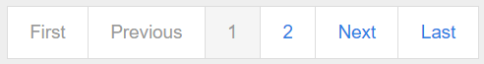

Property Details
You can view details of any Property presented on the Properties List by clicking the details button next to specific Property.
This results in the System displaying the following details of the Property:
- Area of Choice
- Area of City
- Street name with house number and apartment number (if applicable)
- Eircode
- Number of bedrooms
- Whether it is an Apartment Type or a House Type
- In case of House - how the House is situated (e.g., detached, semi-detached, etc.)
- Property Features
- Additional Information text
- Description of the Property (if provided)
- Property photos will also be displayed (if provided)
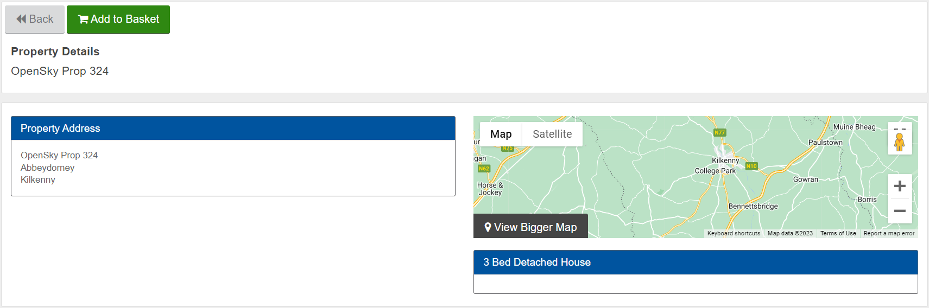

If you wish to return to the Properties List, you must click the back button.
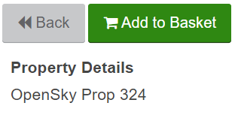

Property Map
When viewing the Property Details, you can see the Property's location on the map. If you find the map too small, click the link to open the map in another window.
You also have the possibility to view the surroundings of the Property using Google Street View - to do so drag and drop the Street View icon near the Property location on the map.
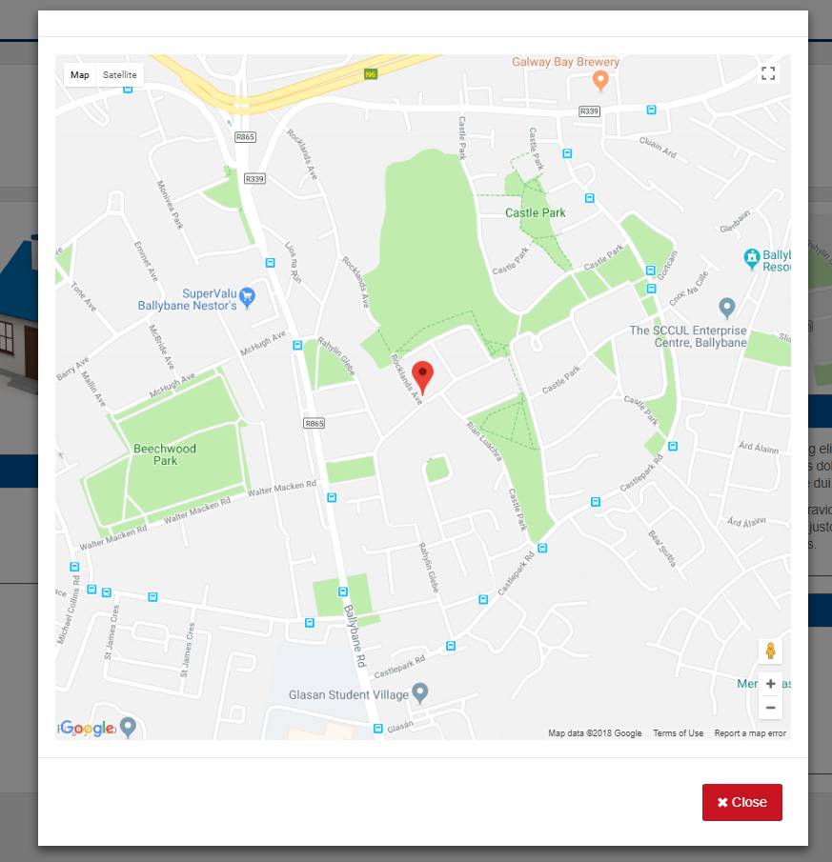

Add Property to Basket
When viewing Property details, you can add the Property to the Properties Basket.
- Click "Add to Basket" button.
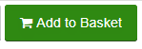
- If this is the first Property in the Basket, the System displays the Basket link to clearly indicate that it is available for Checkout. The fact that the property has been added to the basket will also be reflected in the Properties list.
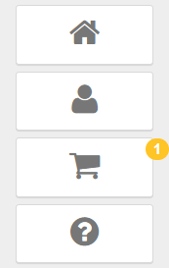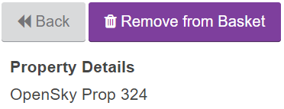

View Properties Basket
When there is at least one Property in the Basket, you can view its contents.
- Click the Properties Basket button.
- The System then displays all Properties that have been added to the Basket as a list. The System also displays a button that allows you to remove the Property from the Basket

Remove Property from Basket
After you have added the Property to the Basket, you are able to remove that Property from the Basket before submitting the Basket. You can also remove your interest in a property at any point before the admin period has ended. The Default Admin periods are set to operate from 00:00 every Wednesday Morning and end at 23:59 every Tuesday Night.
There are two ways to remove a property from the basket:
- When viewing its details: After you have added it to the Basket the button for adding to the Basket is substituted with the button to remove it from that Basket. Once removed, a popup message will show that it has been removed.
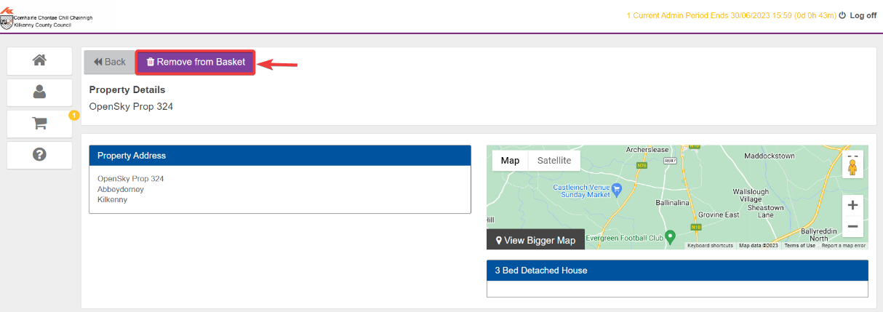
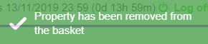

- When viewing the Basket: For each item in the Basket I get the button that allows removal from the Basket.
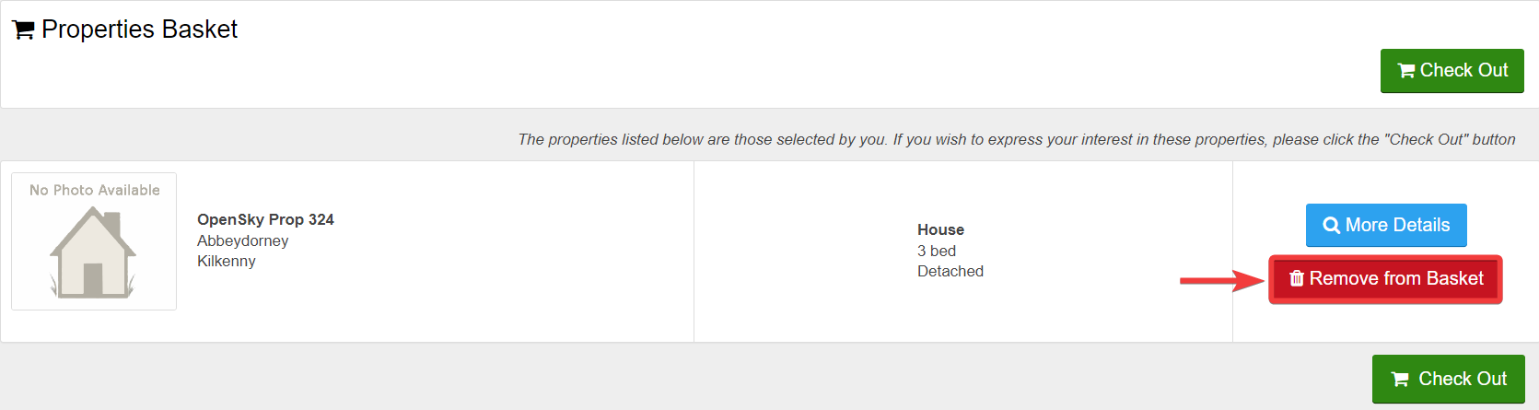
If you click either of these buttons the System removes the Property from the Basket and if you view that Property again you can add it back to the basket the same way that you added it before.

Check Out / Submit Basket
- When you decide that the composition of the Properties Basket is to your liking click the button to check the Basket out.
- Once you review the Basket on the Checkout stage and are sure you wish to express your Interest in these selected Properties click the “Check Out” button.
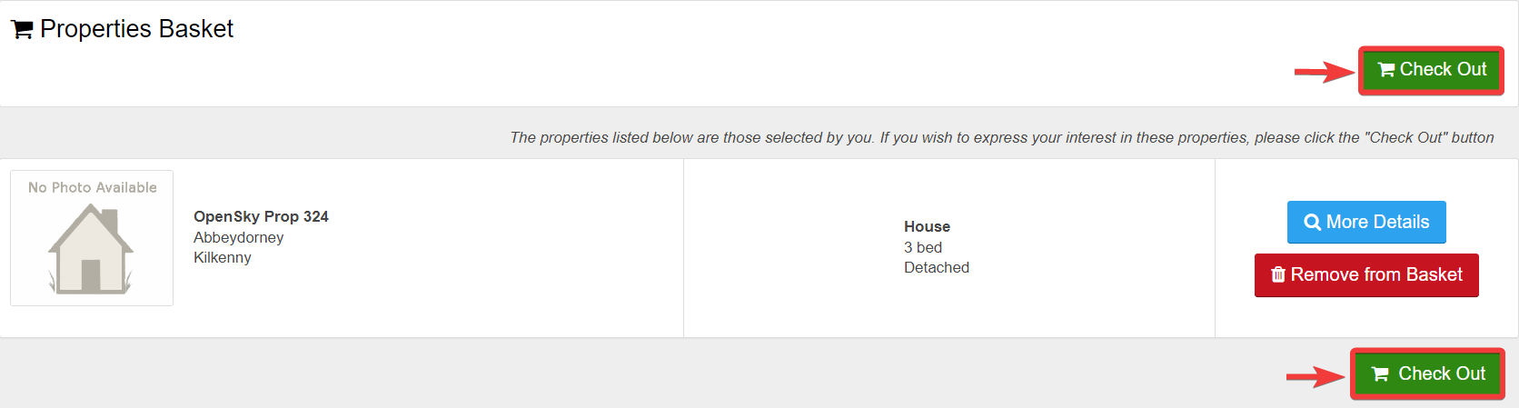

- Before submitting you are required to tick two checkboxes - one for agreeing to Terms & Conditions (view the T&C by clicking provided link) and another for stating that you will accept the Property when offered by the Council. If you express interest in the Property but do not accept it when offered, you will be suspended from CBL scheme for a period of time. Only after these checkboxes are ticked are you able to click the “Submit” button.
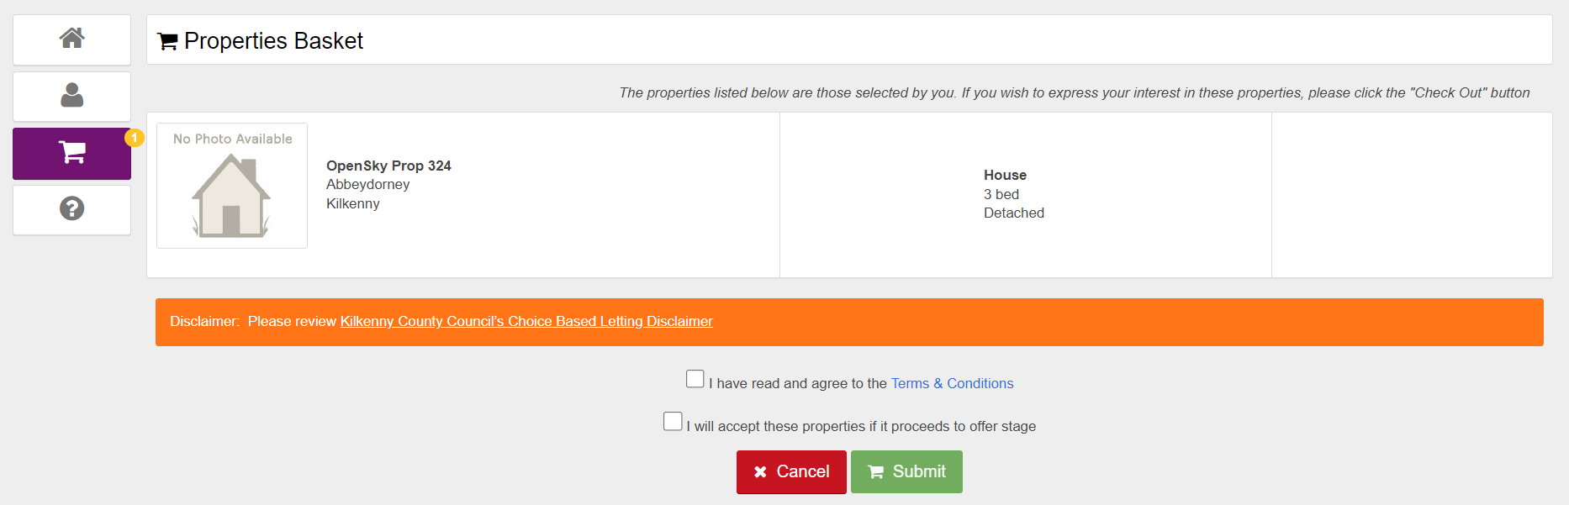
- This is the last place where you can cancel submitting the Basket - to do so click the Cancel button, which will bring you back to the Checkout screen. If you decide to confirm at this stage your Expression of Interest is recorded against each of selected Properties.
- In the case that Properties in your Basket that you haven’t yet Checked Out and the CBL Period has ended then they will be removed from that Basket automatically.

View Reciept
Once you have successfully submitted the Properties Basket you are presented with the Properties Receipt - a list of Properties that you have just expressed the Interest for - the list is presented on the Checkout screen but with that difference that instead of buttons, next to each Property to which your Expression of Interest was successfully recorded for is displayed.
You are given two options on how to follow up:
- “Back to Properties”
- “Log Out”

View Submitted Properties
You are able to view the list of Properties that you have expressed interest in during current CBL Admin Period.
- Open the Selected Properties tab and there you can view the list of all Properties that you have added to the cart and then submitted.

- The Properties are displayed with the most recently submitted at the top and it is still possible to view their details.

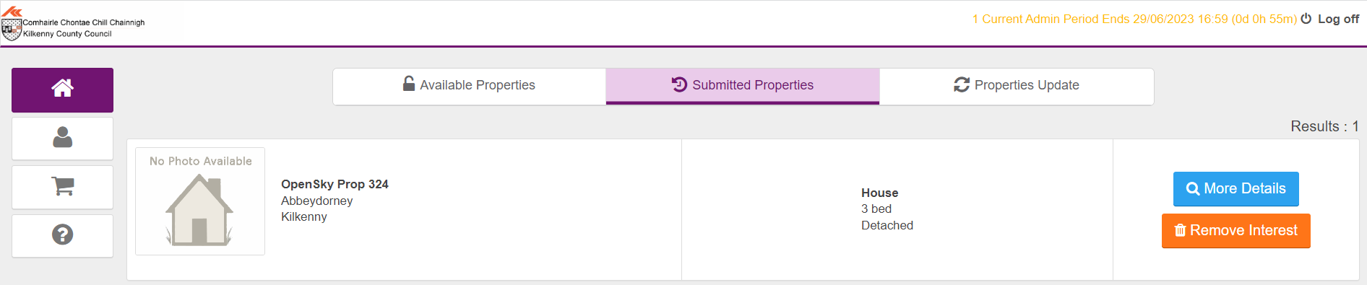

Remove Interest for Property
Once you have expressed interest for a Property you can remove that interest but only as long as the CBL Admin Period does not change.
- Click View Details on Checkout Properties list.

- Remove the interest by clicking "Remove My Interest”.

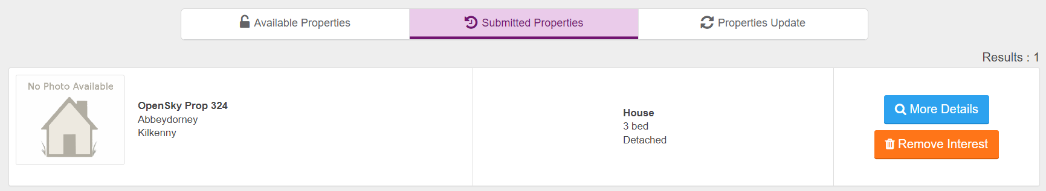

- You will receive a confirmation popup of the removal as shown:

